**Computer Vision Assignment**

**Problem Statement:**

You are given an image with 2 pencils(A & B) kept at an angle as shown below and we want to know the length of pencil-B as well as the angle at which these pencils are placed.

**Use computer vision techniques to find out:**

**a) Length of pencil-B.**

**b) Angle at which pencils are placed with each other.**

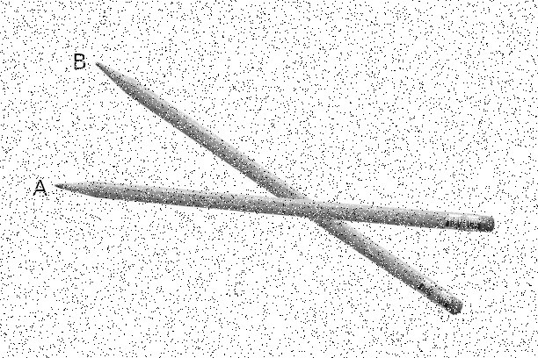

**Submissions:**

Submit your project and its related files in a zip format. Incase you are using any external packages create a requirements.txt file clearly mentioning the version number of these packages or libraries.

Your project should have an executable file “main.py” incase you are using python that should generate or print the outputs.